{{DATE}}

**{{CLIENT_NAME}}**

**{{ADDRESS}}**

**ATTENTION: {{CONTACT_PERSON}}**

Dear Sir/Madam,  
  
We take special pleasure in submitting our firm quotation for the KYOCERA DIGITAL COPIER TASKalfa 6004i as follows:

**BLACK ‘n WHITE COPY & PRINT, COLORED SCAN**

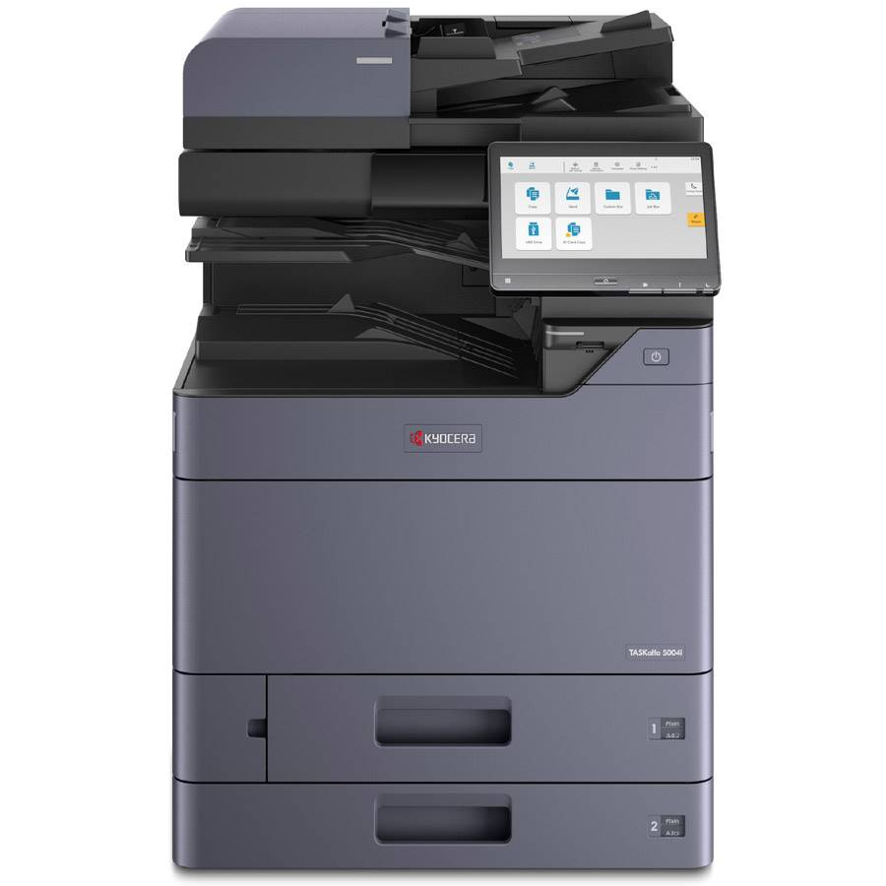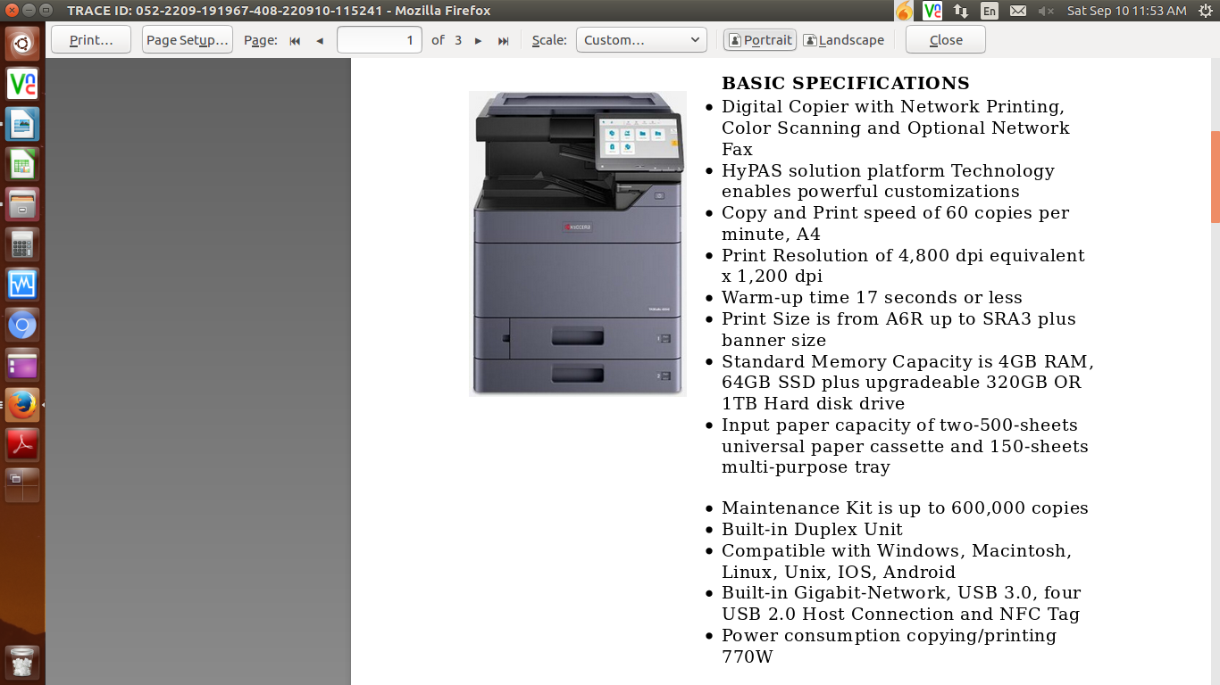

* **PRICE OF THE MACHINE**

|  |  |  |
| --- | --- | --- |
| 1 unit of KYOCERA DIGITAL COPIER TASKalfa 6004i | Php | **564,000.00** |

**SPECIAL PROMO:**

MACHINE REGULAR PRICE Php 564,000.00

LESS PROMO DISCOUNT Php 134,400.00

TOTAL DISCOUNTED AMOUNT PHP 429,600.00 (LESS 15% IN CASH = PHP 365,160.00)

PHP 17,900/MO. FOR 24 MONTHS (CREDIT CARD)

* **OPTIONAL/ACCESSORIES (NOT INCLUDED IN THE QUOTED PRICE)**

DOCUMENT PROCESSOR (AUTO-FEEDER) Php 62,000.00 (LESS 10% IN COD)

WIFI DIRECT/WIRELESS LAN Php 8,000.00 (LESS 10% IN COD)

STEEL TABLE/CABINET/PEDESTAL Php 6,200.00 (NET PRICE)

LIFETIME SERVICE WARRANTY Php 14,400.00( NET 0F 25% DISCOUNT)

ADDITIONAL PAPER CASSETTE (TWO 500-SHEETS) Php 98,600.00 (LESS 10% IN COD)

DOCUMENT FINISHER Php 302,400.00 (LESS 10% IN COD)

ATTCHEMENT KIT (REQUIRED FOR DF) Php 15,600.00 (LESS 10% IN COD)

* 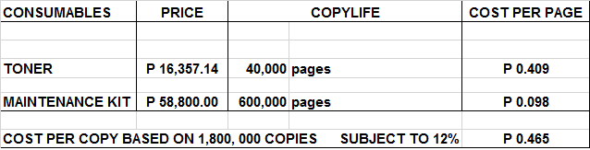**PRICE OF CONSUMABLES**

**Terms of Payment:** CASH/INSTALLMENT  
  
**VALIDITY:** Prices are subject to change without prior notice, please confirm with us before the finalization of the order.  
  
**WARRANTY:**   
  
KYOCERA DIGITAL PLAIN PAPER COPIERS are guaranteed spare parts replacement FREE OF CHARGE for TWO (2) years, or up to 600,000 copies/print/scan whichever comes first.  
  
Warranty for accessories and options is ONE (1) year from the date of delivery.  
  
We also assure prompt service whenever you need assistance. Repair service is FREE for TWO (2) years within Metro Manila. Should our machine require prolonged service, we shall install a backup unit immediately for your convenience.  
  
Installation and Training of Personnel: Our expert service engineers install all our machines and they will be glad to train interested personnel on the detailed mechanics of the machine free of charge.

Moreover, the amount quoted above excludes the cost of any required tests or medical certifications such as, but not limited to Rapid tests, Antigen tests, and RT-PCR tests. The actual cost will be billed separately

We are looking forward to hearing from you soon. For any questions or concerns, please feel free to call us at 7618-0274.

Very truly yours, Conforme:

**JAYPEE V. SONIEL __________________________________**  
SENIOR ACCOUNT EXECUTIVE II

09176240820 (Viber Ready)